Unit 3: Lesson 16
Managing Our Thoughts
Goal: To learn that the social and emotional positive action of managing our thoughts helps us feel good about ourselves.

What goes on in the space between our ears has a lot to do with how we feel about ourselves. Our minds are always thinking.
Wesley was thinking about a nap. He was waiting for a friend – who was late. He leaned back and closed his eyes. Drifting off to sleep, Wesley dreamed that he felt a thump and heard a loud buzzing in his ear. He swatted at his ear. “Crazy bee! Get out of here!”
“Well, don’t be sleeping in my way,” was the bee’s comeback. “You’re lucky I didn’t sting you. By the way, I hope you don’t mind my saying so, but that was the most cluttered place I’ve ever seen!”
“Huh?” asked Wesley. “What are you talking about?”
“That place I saw from inside your ear. Thoughts were lying all over the place. You really ought to manage your thoughts.”
“Manage my thoughts?” Wesley said aloud. The sound of his own voice woke him up.
He sat up and rubbed his eyes. “What a strange idea!”

Even though managing our thoughts might be a new idea, it’s a positive action that helps us feel good about ourselves. We manage our thoughts by choosing how and what to think rather than by just dwelling on whatever thoughts come into our minds.
We learned the importance of thinking positive thoughts in Unit 1. The Thoughts-Actions-Feelings Circle showed us that positive thoughts lead to positive actions, which lead to good feelings about ourselves. By managing our thoughts, we can think positive thoughts more often; we can become positive thinkers. Positive thinkers are people who feel good about themselves because their positive thoughts continually lead them to do positive actions.
To become a positive thinker, we need to dwell on clear, honest, and caring positive thoughts. In order to do so, we must fill our minds with the best information, with the best ideas, and with the best knowledge we can. We also need to trace our thoughts around the Thoughts-Actions-Feelings Circle. By thinking our thoughts through – that is, seeing the action that the thought starts and the feeling about ourselves it brings – we can trace our thoughts to their results. Then we can see which thoughts will give us good feelings about ourselves if we put them into action…
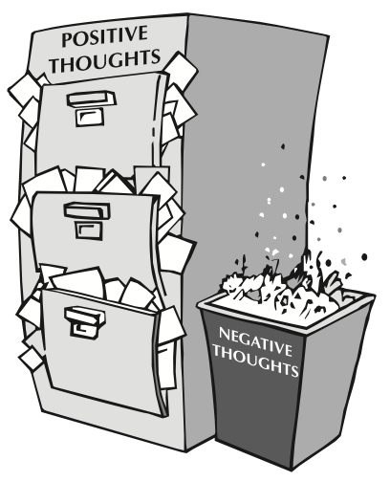
Learning to manage our thoughts positively takes practice. It requires thinking things through till we see the consequences of our thoughts. It requires choosing the best thoughts and then acting on them. It requires always nourishing our minds with positive thoughts, actions, and feelings. Although it takes some time and effort, learning to think positively is one of the most important things we will ever do.
It would be wonderful if thinking positively prevented negative thoughts from coming into our minds, but it doesn’t. However, we can choose not to dwell on negative thoughts by replacing them with positive ones. As we do this, “I can” thoughts will begin to replace the “I can’t.” We will feel better about ourselves and become more competent at thinking positively with each experience in the Happy Circle.
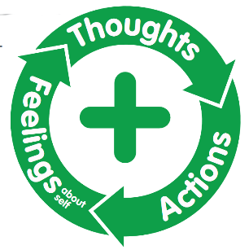
As our thoughts become more positive and lead to positive actions, we see our lives and the lives of those we influence become more positive. Managing our thoughts is a key to success and happiness. Positive thinkers feel good about who they are, what they are doing, and how they treat others. They not only become the best they can be, they give their best to those around them. Let’s think about what we’re thinking about.

QUESTIONS:
- What is the purpose of managing our thoughts?
- How can we manage our thoughts?
- How do we choose the thoughts we think?
- How do you manage your thoughts about yourself, other people, or your situations?
- Do you realize that you can always choose positive thoughts? How will this positive thinking affect how you feel about yourself?
- How do you feel when you manage your thoughts by choosing positive ones?
Let’s start reinforcing our positive thoughts. Think of a time when you deliberately chose a positive thought over a negative one. Tell your family about it. Talk about how you felt about yourself as a result of managing your thoughts positively.
Become more aware of the thoughts you are thinking. Identify thoughts that lead to positive actions. Begin to manage your thoughts by looking for positive thoughts in every situation. When you find yourself thinking negative thoughts, replace them with positive ones. It may not always be easy but keep trying.
parent positive actions
Ask Yourself: How do you choose which thoughts you think about? What kinds of thoughts do you have about your family? Do these thoughts help you feel good about yourself as a parent? If not, how could managing your own thoughts improve you feel about yourself as a parent?
Plan and Do: Think positive thoughts about yourself as a parent. When negative thoughts try to batter your self-concept as a parent, replace your negative thoughts with these positive thoughts about yourself. Help you children understand that they, too, can manage their thoughts in positive ways.

FAMILY POSITIVE ACTIONS:
QUESTIONS:
- What effect do positive thoughts have on us as a family?
- What areas of family life could we improve by managing our thoughts?
- How do we feel about ourselves when we choose to think positive thoughts about one another?
Let’s make a family plan to practice the positive action of managing thoughts. As a family, we’ll identify negative situations where we tend to react without thinking, such as morning when things are rushed or when someone doesn’t put things away.
When we find ourselves in these or similar situations, let’s agree to stop and ask “Where will my thought lead?” If we know that thinking “I hate the rush of mornings” is going to lead to a stressed-out day, we can try a different thought such as “Mornings will go better if I plan the night before.”
Remember, if we have a hard time coming up with positive thoughts, we can always ask other family members for help.

COMMUNITY POSITIVE ACTIONS
Let’s practice managing our thoughts while we are out in our community. By managing our thoughts in a positive way, our community can become more positive.
Let’s make a list of the good thoughts about our community and then choose an area in which to get involved.
When we’re faced with negative situations in our community, let’s agree to use these thought-management skills to find positive thoughts for those situations.

SUMMARY
Wesley like the idea of managing his thoughts. The more he thought about it, the more sense it made to him. If he could manage his thoughts, he reasoned, he could change his life in positive ways. And that would make him feel good about himself.
We, too, can manage our thoughts. We are not limited to the thoughts that just pass through our minds. We can pick and choose which thoughts we want to think about. Managing our thoughts helps us think more positively.
As we think more positively, new levels of thinking open up to us. We begin thinking new ideas, analyzing new thoughts, and reasoning in different ways. And as positive thinkers, we’ll feel good about ourselves because our positive thoughts lead us to do positive actions.

Word of the Week: Thoughts
Ideas that result from thinking.

